The “One Another” Commandments
of the New Testament
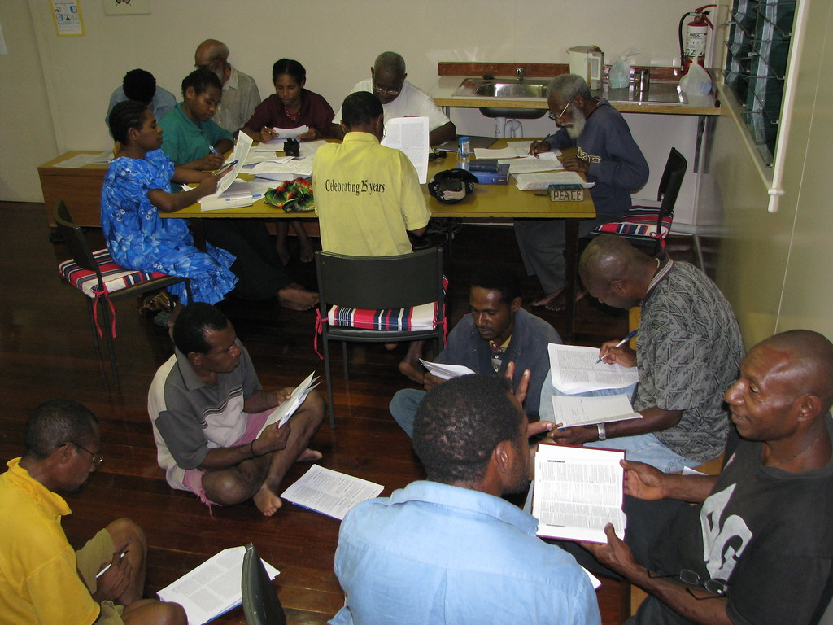
Photo credit "Rich Inductive Bible study" by kahunapulej is licensed under CC BY-SA 2.0
How To Live In Christian Community
By John Edmiston
©Copyright John Edmiston 2021, Creative Commons, may be freely used for non-profit ministry purposes but may not be sold in any way.

Table of Contents
A Quick Introduction – page 3
Love One Another – page 4
Serve One Another – page 5
Encourage One Another – page 6
Forgive One Another – page 7
Instruct One Another – page 8
Bear Each Other’s Burdens – page 9
Be At Peace With One Another – page 10
Show Hospitality To One Another – page 11
Be Patient With One Another – page 12
Honor One Another And Be Humble – page 13
Contact Details / About the Author – page 14

A Quick Introduction
The Greek word for “one another” is αλλελων (allelon - pronounced allel-own), and it is used 100 times in the New Testament. The most prominent of these is “love one another” which will be our first Bible study.
Most of these “one another” references are direct commandments and the expectation is that they were to be obeyed by the readers of the Gospels and Epistles. They were meant to be put into practice!
These “one another” commandments are the commandments that construct community, such as instruct one another, encourage one another and offer hospitality to one another. They take us out of our isolated selfishness and into God’s plan for our lives as Spirit-filled new creations full of faith and love.
“One another” means community, it means that we are not to do the Christian life on our own. It also means that being nice to other human beings is a very necessary part of obeying Jesus Christ.
Despite all the COVID lockdowns we still need other human beings as part of our Christian faith, we cannot fully live out what it means to be a Christian from behind a computer screen or on a mobile phone.
Most of these commandments were meant to be carried out in the context of a local parish church. These members were people who knew each other and met every week for prayer, teaching and the Lord’s Supper. They were the household of God in a particular city, and they were brothers and sisters in Christ.
Someone once said that “fairness is treating everyone differently”; we automatically expect different responses from a 6-year-old and a 25-year-old. These members in the parish church knew each other and were able to be considerate and kind to one another in ways that were tailored to the particular needs of each member. The orphans and widows would need one kind of mercy, while the elders who taught well would need another.
Some teachers might argue that these studies are a very behavioral approach to the Christian life. On the other hand, our behavior is our true doctrine! It is no use behaving selfishly while espousing a deep knowledge of the theological implications of agape love.
One of the oft-repeated themes of Scripture is that the Lord judges us on how we behave toward other human beings. God is merciful to those who are merciful (Matthew 5:7) is bountiful to those who are generous (Luke 6:37-38) but is relentless and harsh to those who are cruel and unforgiving (Matthew 18:21-35).
The Scriptural rule-of-thumb is that God treats us in the same way that we treat other people, especially the poor, the vulnerable and those we have power over such as our employees. In the context of divine judgment of our Christian lives at the judgment (bema) seat of Christ (2 Corinthians 5:10), the one another commands become very important.
The emphasis of this series of studies will be more practical than theological, and the aim will be for you to put this into practice in your small group and in your church. If you are the Bible study leader, please encourage much discussion of the practical aspects and outcomes of these commandments.

Love One Another
Bible Verses: John 13:34-35 and 15:12-17; Romans 12:9-10 and 13:8-10; 1 Thessalonians 3:12 and 4:9; 2 Thessalonians 1:3; 1Peter 1:22, 3:8, and 4:8; 1 John 3:11-23 and 4:7-12; 2 John v5; 1 Corinthians 13:1-3; Matthew 24:12-13

- Read John 13:34-35 and 2 John v 5. What is the New Commandment? What does it mean by “just as I have loved you”? What will people know when we obey this commandment of Christ? (John 13:35)
- Read John 15:12-17 and 1 John 3:11-23. How does Jesus Christ call us to practical sacrificial love for one another? What are some ways that this might work out in practice?
- Read 1 John 4:7-12. Love is from God because God is love. Discuss all the things that these few verses tell us about the nature of love!
- Read Romans 13:8-10. How does love fulfill the law? How do we meet God’s spiritual expectations of our lives? What are we like spiritually if we do not have love? (1 Corinthians 13:1-3)
- Read Romans 12:9-10. How can we love people by honoring them and showing brotherly love? How is this the opposite of “cancel culture”? How can we heal broken people by honoring them?
- Read 1Thessalonians 3:12, 4:9 and 2 Thessalonians 1:3. How was the church in Thessalonica an example of Christian love despite enduring much persecution? How did God teach them to love one another? (1 Thessalonians 4:9)
- Read 1 Peter 1:22, 3:8 and 4:8. What does it mean to earnestly/fervently love one another? Why does love grow cold? (Matthew 24:12-13)
- What is the difference between practical agape love and mere sentimental affection? (1 John 3:16-18)
- What are some practical ways in which we can love people who are often unloved - such as the lonely, the elderly, and the disabled?

Serve One Another
Bible Verses: John 13:1-17, 1 Corinthians 3:1-3, 11:20-22 and 33-34; Galatians 5:13-14 and 6:2; 1 Peter 4:8-10

- Read John 13:1-11. What radical action did Jesus Christ perform? What did Jesus “know” about Himself even before He did this prophetic action? (John 13:1-4). How does this help us to be humble servants of God?
- Read John 13;12-17. What did Jesus teach the disciples to do? How were they to behave in the light of what he did? How can we put this into practice ourselves?
- Read 1 Corinthians 11:20-22. What was the problem in the church in Corinth? How was this a sign that they were carnal Christians and not filled with the Spirit? (1 Corinthians 3:1-3)
- Read 1 Corinthians 11:33-34. What instruction did Paul give to solve the problem at Corinth? What does it mean to “wait” for one another at a meal, or on various life occasions?
- Read Galatians 5:13. How can a sense of spiritual freedom lead some people to become selfish and unconcerned for the welfare of others?
- Read Galatians 5:13,14. What is “through love serve one another”? What does it mean to be a holy servant of the saints?
- Read Galatians 6:2. How does bearing one another’s burdens fulfill the law of Christ (to love one another)? How can we help people who are being crushed by the burdens of life?
- Read 1 Peter 4:8-10. How is hospitality a prime example of loving one another? How have you felt when you were the recipient of very gracious hospitality? Why are we often tempted to grumble when we show hospitality, especially when people stay with us for some time?
- What is the relationship between serving one another and being humble?

Encourage One Another
Bible Verses: Acts 27:21-26, 33-38; I Thessalonians 2:11-12, 4:13-18, 5:9-11,14; Hebrews 3:13, 10:24,25; Ephesians 6:21-22; Romans 1:11-12; Colossians 2:1-3; Genesis 21:14-20
- Read Acts 27:21-26, 33-38. How did Paul encourage the sailors on the ship in the storm? Why did Paul have hope for deliverance? Why does God send angels when people are in crisis and despair (Genesis 21:14-20)?
- What is the purpose of Paul’s fatherly exhortation and encouragement in 1 Thessalonians 2:11-12? What was the desired outcome in their lives? (In the Bible, encouragement is not just a nice feeling, it has a purpose for people to “be” a certain way or to “do” a certain thing.)
- How does Paul use sound doctrine to encourage Christians about the End Times in 1 Thessalonians 4:13-18 and 5:9-11? How does good doctrine keep us from being hopeless and afraid?
- Read 1 Thessalonians 5:14. What sort of people are we to encourage? How can we do this?
- Why are we to exhort and encourage one another in Christ on a daily basis? (Hebrews 3:13 and 10:24,25)
- Read Ephesians 6:21-22. Why did Paul send Tychicus to the Ephesians? What does it mean to have a ministry of encouraging people’s hearts?
- Read Romans 1:11,12. What was Paul’s purpose in desiring to visit the church in Rome? How can imparting spiritual gifts be a form of encouraging Christians in the faith?
- Read Colossians 2:1-3. What spiritual outcomes is Paul aiming for as he struggles in prayer for the Colossians and for those in Laodicea?
- Why is discouragement such a potent weapon of the Devil? How is it our duty to ensure that our brothers and sisters are not swallowed up by despondency and discouragement in life?

Forgive One Another
Bible Verses: Ephesians 4:31-32; Colossians 3:12-14; James 5:15-16; Matthew 6:12-15, 18:21-35; Mark 11:25; Luke 6:37-38, 17:3-4; 2 Corinthians 2:6-8; Hebrews 12:15
- Read the Parable of the Unmerciful Servant in Matthew 18:21-35. What does it teach us about the importance of forgiving others from the heart?
- What are the blessings of being a person who forgives easily and readily? (Luke 6:37,38)
- How are repentance and forgiveness linked (Luke 17:3-4) and how often are we to forgive the truly penitent?
- Read Ephesians 4:31-32; Colossians 3:12-14. What is the theological basis for our forgiveness of other people? (Hint, there are two of them and one is not obvious.)
- How is forgiveness and unforgiveness tied in with our prayer life? (Matthew 6:12-15; Mark 11:25)
- How does bitterness (persistent unforgiveness) defile us spiritually? (Hebrews 12:15)
- Read 2 Corinthians 2:6-8. How can withholding forgiveness from a penitent person be emotionally and spiritually destructive?
- How is confession and forgiveness a potent force of healing? (James 5:15,16)
- What happens to people who constantly try to forgive an unrepentant, lying, and abusive sociopath? Why do we need a few boundaries around forgiveness? Should we just forgive all the criminals and let them out of jail? If not, why not, and how do we use wisdom and discernment in the exercise of forgiveness?

Instruct One Another
Bible Verses: Acts 5:19-21, 11:26, 14:21, 28:31; Romans 15:14; Colossians 1:28, 3:16; 1 Thessalonians 5:11; Ephesians 5:19; Romans 14:19; 1 Corinthians 14:3; 1 Timothy 4:11, 4:6; 2 Timothy 2:2, 22-24; Titus 2:4; 1 John 2:20,27
- Read Acts 5:19-21, 11:26, 14:21, and 28:31. How important was Bible teaching in the ministry of the apostles?
- Read Colossians 1:28. What is the aim and proper purpose of Bible teaching?
- Read Romans 15:14; 1 Thessalonians 5:11; 1 John 2:20,27. How do spiritually mature people instruct one another? Is it just the pastor doing all the teaching?
- Read Ephesians 5:19 and Colossians 3:16. How is instructing one another a natural outcome of a Spirit-filled, Bible-believing lifestyle?
- Read Romans 14:19, 1 Corinthians 14:3. How important is mutual edification?
- Read 1 Timothy 4:11, 4:6. What was Timothy to do as the senior pastor of the church in Ephesus?
- Read 2 Timothy 2:2, 22-24. Timothy was to also raise up other Bible teachers. What were some of the qualifications of these new teachers?
- Titus 2:4 is an example of peer-to-peer instruction. What were the older women to teach the younger women during that time and culture? How could this be extended to youth teaching other youth, men instructing other men, or even people in recovery helping others in recovery?
- What are some things (if any) that only trained ministers of the gospel should teach, e.g. complex doctrine? How do you think teaching should be structured in the Church?

Bear One Another’s Burdens
Bible Verses: Acts 2:42-47, 4:32-37; Galatians 6:2; Acts 20:35; 1 Thessalonians 5:14; Titus 3:14; James 1:27, 2:8; Romans 13:8-10, 15:1; Philippians 2:1; 1 Peter 3:8; 1 John 3:16-18; James 2:15-16, 5:4-6; 1 Timothy 5:3-16

- How does “bearing one another’s burdens” fulfill the law of Christ? (Galatians 6:2; James 2:8; Romans 13:8-10) What kind of burdens do people have and how can we lift them from their shoulders?
- Read Acts 20:35. What is meant by this brief saying of the Lord Jesus Christ? See also Romans 15:1

- Read Acts 2:42-47, 4:32-37. How did the apostolic Jerusalem church help each other so that poverty was eliminated?
- Read James 1:27. How are we to help widows and orphans? How does this also apply to other vulnerable members of society today such as the elderly and the disabled?
- Read 1 Timothy 5:3-16. In this passage, there is a long list of wise advice about how to help widows. How can these instructions be recontextualized to helping vulnerable people in society today? How strong is the admonition in 1 Timothy 5:8
- Read 1 John 3:16-18 and James 2:15-16, 5:4-6. How did the altruism of Acts give way to the utter selfishness displayed in the book of James?
- What sort of attitudes should be common among Christians (1 Peter 3:8; Philippians 2:1)? How is mean-spiritedness the precise and utter opposite of the love of Christ?
- Read 1 Thessalonians 5:14 and Titus 3:14. How should pastors instruct their congregations when it comes to helping other people?
- If society totally collapsed due to a nuclear war, how could Christian churches and bible study groups help their members to survive?

Be at Peace With One Another
Bible Verses: Mark 9:50; Romans 12:9-21; Romans 14:17-19, 15:5-7; 1 Corinthians 7:15; 2 Corinthians 13:11-14; Ephesians 4:1-6; Hebrews 12:14; James 3:17-18; 1 Peter 3:8-11

- Read Mark 9:50 and Hebrews 12:14. There is often a tension between being truthful (salty) and being harmonious. Where do you think you fit on a spectrum between being very “truthful” and being very “harmonious”? How can worldly compromise for the sake of peace get us into spiritual trouble?
- Read Ephesians 4:1-6. What is the basis for the unity of the Spirit and how does it form the “bond of peace”?
- Read Romans 12:9-21. How could these commandments form a good basis for living in Christian community?
- Read Romans 14:17-19 and 15:5-7. The Roman Christians had some major divisions, between Jew and Gentile, between the strong in the faith and the weak in the faith, and it seems, between the rich traditional free Romans and the others (such as Christian slaves) in the church. How does the advice in these verses give a sound basis for healing such divisions?
- Divorce is awful, yet sometimes relationship breakdowns occur. What is Paul telling us in 1 Corinthians 7:15?
- Read 2 Corinthians 13:11-14. How does Paul conclude this rather severe epistle to the Corinthians and what can we learn from these verses about how to live in Christian community?
- Read James 3:17,18. What is the relationship between godly wisdom and making peace in community?
- Read 1 Peter 3:8-11. The Apostle Peter gives instructions on seeking peace and pursuing it. Which attitudes are involved? What are we to turn away from? How are we to control our speech?
- A very divisive heretic comes into a church and actively spreads false doctrine. How does this violate the unity of the Spirit? What should the church leadership do? How does confronting false doctrine and division contrast with being at peace with all men?

Show Hospitality To One Another
Bible Verses: Genesis 18:1-10, 19:1-3; Judges 13:15; 1 Kings 17:8-16; Matthew 10:40-42, 25: 41-46; Luke 10:25-37; Romans 12:8,13; 1 Timothy 3:2, 5:9,10; Titus 1:8; Hebrews 13:2; 1 Peter 4:8,9,

- How is hospitality a fundamental requirement of Christian leadership? (1 Timothy 3:2; Titus 1:8)
- Read 1 Timothy 5:9,10. What are some of the attributes of a holy widow and how do they relate to a lifestyle of kindness and hospitality? How do holiness and hospitality work together?
- Read Romans 12:13. How were the wealthy Roman Christians to act toward those in need?
- Read 1 Peter 4:8,9; Romans 12:8. How is cheerful hospitality a proper expression of fervent Christian love?
- Why are we to be hospitable to strangers? (Hebrews 13:2; Genesis 18:1-10, 19:1-3; Judges 13:15)
- What are the benefits of showing hospitality to the servants of God? (Matthew 10:40-42)
- What are the dire spiritual consequences for those who fail to show hospitality? (Matthew 25:41-46)
- How is the Good Samaritan an example of deep and practical hospitality? (Luke 10:25-37)
- How does exercising hospitality sometimes stretch our faith in God? (1 Kings 17:8-16)

Be Patient With One Another
Bible Verses: Ephesians 4:1-3; Galatians 5:15, 22-23; Colossians 1:11-12, 3:12-13; Romans 14:13, 15:5; 1 Thessalonians 5:14; 2 Corinthians 12:12; 2 Timothy 4:2; James 5:7-11; Matthew 10:11-15; Acts 13:50,51
Note: There are three kinds of patience: firstly, patience with an arduous task such as a farmer waiting for the crop to mature; secondly, patience with one another which involves not over-reacting to individual people who may be aggravating; thirdly, patience with suffering and persecution. This study will focus on “patience with one another”.
- Read Ephesians 4:1-3 which talks about “good Christian manners” or rather walking “in the manner” which we have been called (to be like Christ). How are humility, gentleness, patience and bearing with one another in love all part of being a well-mannered and Christ-like person?
- Read Colossians 1:11-12. Paul prays that the Colossians will be filled with God’s power “for all endurance and patience with joy”. Why do we require God’s power and strength if we are to be patient with people?
- Read Colossians 3:12-13. What does it mean to “put on” Christian virtues such as patience? How can we discard impatience and instead clothe ourselves with patience and kindness? How can we get rid of old grumpy habits? What does it mean to “bear with one another”? How can we bear with the worship music of other generations?
- Read Galatians 5:15, 22-23. How do the fruit of the Spirit prevent us from devouring one another?
- Read Romans 14:13, 15:5. Why do we have to stop passing judgement on one another? How does endurance enable us to live in harmony with one another?
- Read 1 Thessalonians 5:14; 2 Corinthians 12:12; 2 Timothy 4:2. How are God’s servants to be patient with those that they instruct? How does this contrast with “dusting off one’s feet”? (Matthew 10:11-15; Acts 13:50,51)
- Read James 5:7-11 and discuss how these verses show all three kinds of patience at work in the Christian life?
- The stories we make up in our heads about people lie behind whether we are patient or impatient with them. For instance, we can say, “Oh, I will be patient with that person because they are old and infirm”. How can we change our stories, judgments and expectations of others so that we become more kind, patient and forbearing?
- We tend to become impatient when we are in a hurry. How can we develop a less pressured view of time and urgency so that we can be more compassionate with people?
Honor One Another And Be Humble
Bible Verses: Matthew 15:1-8, 20:20-28; Luke 14:7-11; Romans 12:10, 13:17; 1 Corinthians 12:26; Ephesians 5:21-33; Philippians 2:3, 29-30; Colossians 3:18-25; 1Timothy 5:8, 17-18; 1 Timothy 6:1; 1 Peter 2:17, 3:7

- Read Matthew 20:20-28. In this passage, what lesson did Jesus teach the Twelve? How did Jesus embody this teaching in His own life? How does it apply to us today?
- Read Luke 14:7-11. What are three key points from this teaching of Jesus? How can we trust God to promote us at the right time? What are the places of honor in your area of life and ministry?
- Read Romans 12:10; Philippians 2:3; 1 Corinthians 12:26. How can we honor one another in the body of Christ?
How does honoring one another produce joy? How does jealousy and competition produce misery? How can we outdo one another in showing honor? What is the opposite of honoring one another?
- Read Philippians 2:29-30, 1 Timothy 5:17-18. How should we honor sacrificial diligent Christian workers? What are the excuses that some churches use to greatly underpay their staff?
- Read 1 Peter 3:7; Ephesians 5:21-33; Colossians 3:18-21; 1Peter 5:5. How should we honor one another in the family? Why has this become so controversial?
- Read Colossians 3:22-25; 1 Timothy 6:1. How are we to respect and honor our employers?
- Read 1 Timothy 5:8; Matthew 15:1-8. Why is it important to honor our father and mother and to financially support them if needed? How does God view those who fail to honor their parents?
- Read Romans 13:7; 1 Peter 2:17. How are we to honor the government and are there any limits to this?
- How vital is “honoring one another” to having a vital spiritual life, a happy family and a Spirit-filled local church?

About the Author

John Edmiston B.Sc. B.D. is the CEO of Cybermissions, as well as an author, conference speaker and Bible-teacher. John and his wife Minda live in Virginia, USA. John is available for speaking engagements.

CONTACT

LinkedIn: https://www.linkedin.com/in/johnedmiston/
Email: johned@cybermissions.org
Website: https://cybermissions.org
Books: Biblical EQ https://biblicaleq.com
The Spiritual Continuum https://spiritualcontinuum.org
Downloading Grace from Heaven https://downloadinggrace.com

TO DONATE
Please send checks to: Cybermissions
P.O. Box 40
Rhoadesville, VA 22542 (USA)

You may also donate securely online at: https://cybermissions.org/how_to_donate_to-_cybermissions.html
Cybermissions is a 501(c)3 non-profit incorporated in Virginia and donations are tax-deductible in the USA

